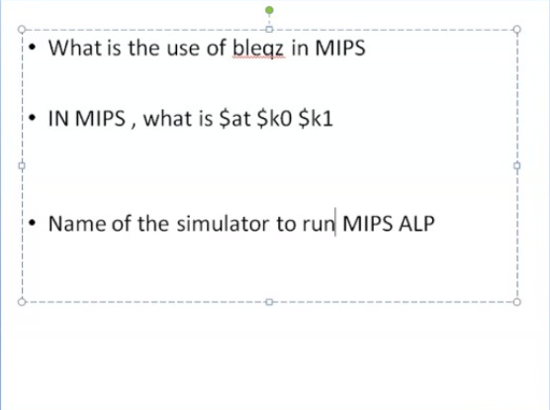

1. What is the use of bleqz in mips

<https://chortle.ccsu.edu/AssemblyTutorial/Chapter-24/ass24_2.html>

1. 
2. Name the simulator to run mips alp

**SPIM** is a **MIPS** processor **simulator**, designed to run assembly language code for this architecture.

SPIM is a simulator

– reads a MIPS assembly language program.

– simulates each instruction.

– displays values of registers and memory